# **Range Rover Sport (L405) 2013-2022**

Land Rover Range Rover Sport (L405) 2013-2022 Air Suspension System has 2 Front Air Struts and 2 Rear Air Spring Bags with 2 Rear Shock Absorbers. Height Sensors tell the Control Module when the Air Suspension Compressor needs to inflate or deflate the Air Suspension System. The Solenoid Valve Block will distribute the Air accordingly trough out the Air Suspension System. Here at BAVARIA CENTER you will find many of the necessary parts and components to fix your Land Rover Range Rover Sport (L405) 2013-2022 Air Suspension System.

# **Land Rover Range Rover L405 Front Left Air Suspension Strut**

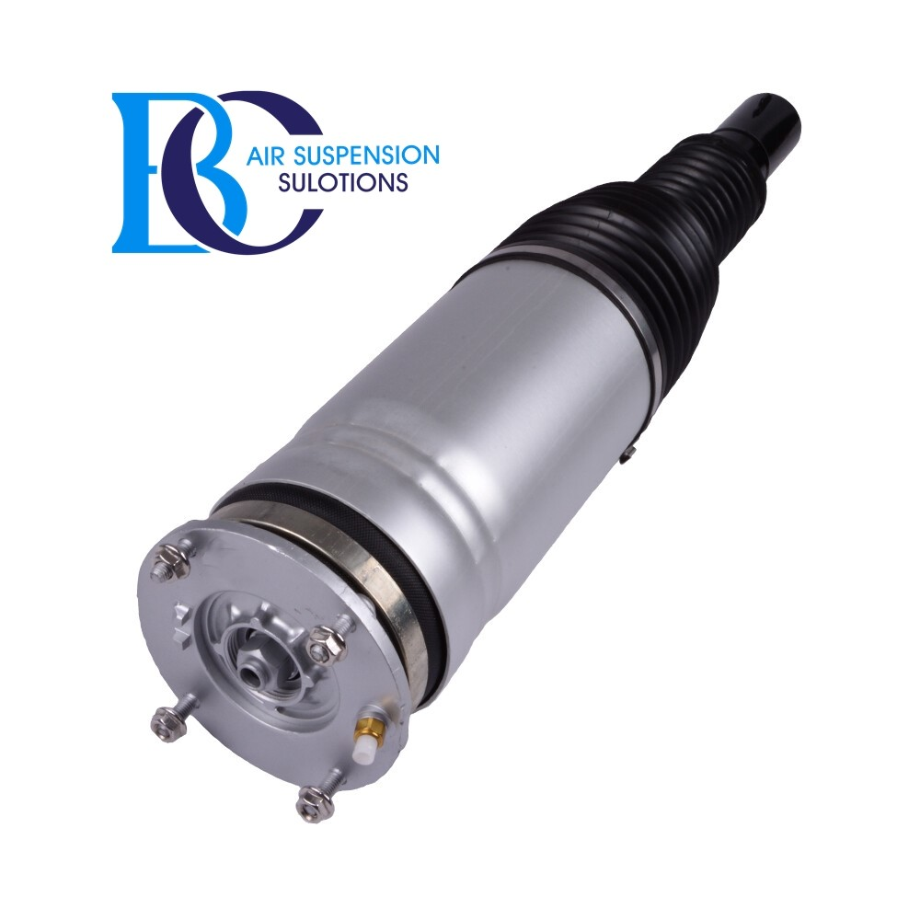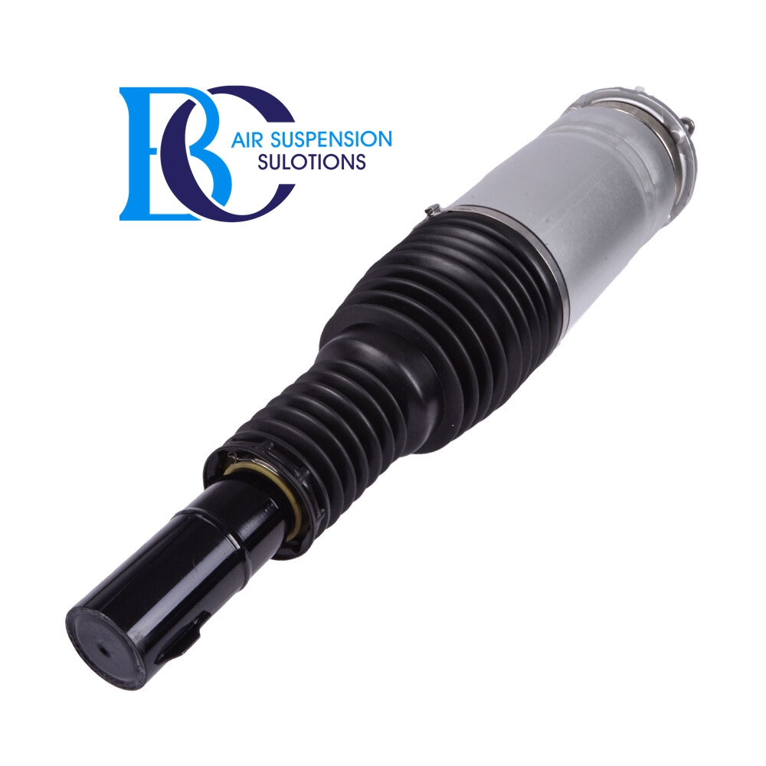

**Description**

This is the Front Left Air Strut for vehicles with Continuously Variable Damping (CVD).

**Can be installed in the following vehicles:**

Land Rover Range Rover IV L405 (2012--)

**Original spare part number:**

LR044852, LR052787, LR057259, LR060401, LR072440, LR087094, LR147907, LR147908,LR045833, LR052788, LR057260, LR060403,LR072216,R087095

# **Land Rover Range Rover SPORT L405 Front Right Air Suspension Strut**

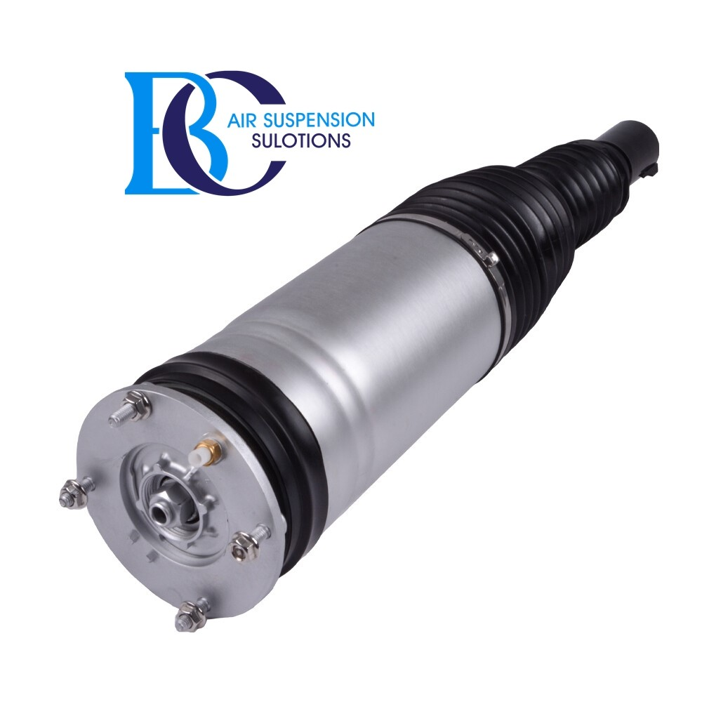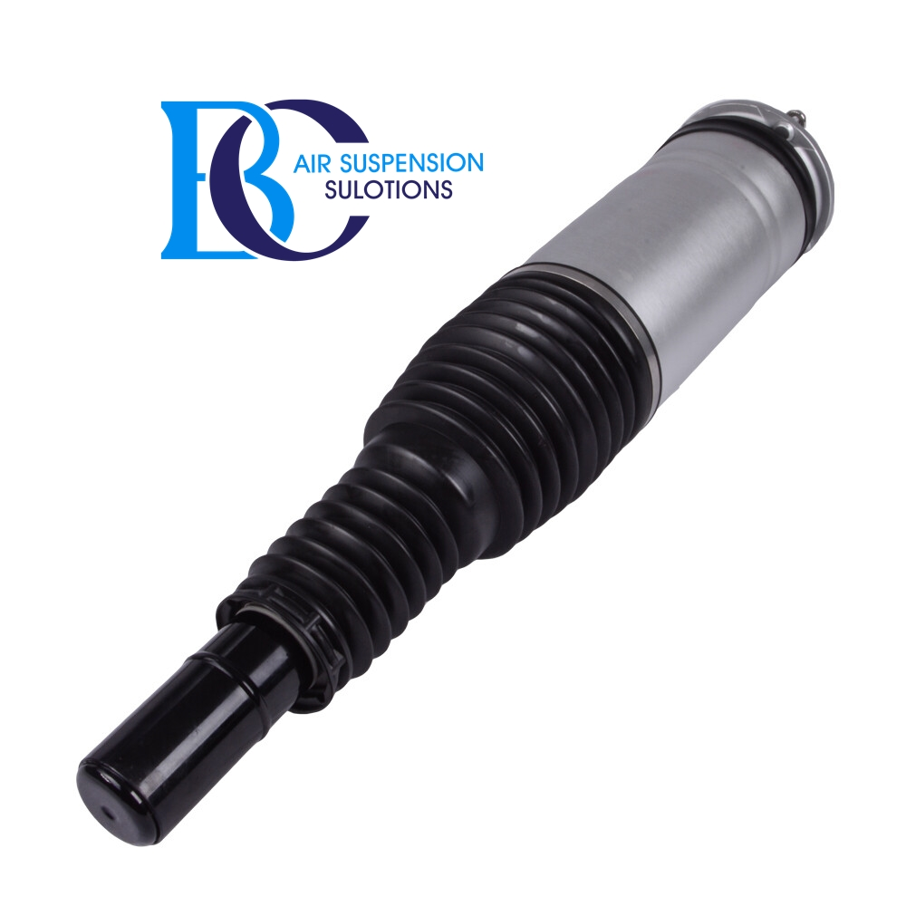

**Description**

This is the Front Right Air Strut for vehicles with Continuously Variable Damping (CVD).

**Can be installed in the following vehicles:**

Land Rover Range Rover Sport II L494 (2014--)

**Original spare part number:**

LR087084, LR045832, LR052785, LR057254, LR060402, LR072215,LR045100, LR052784,

LR057253,LR060399,LR072450,LR147903,LR087083,LR147904

# **Range Rover Sport L405 Air Spring Suspension Kit (FRONT)**

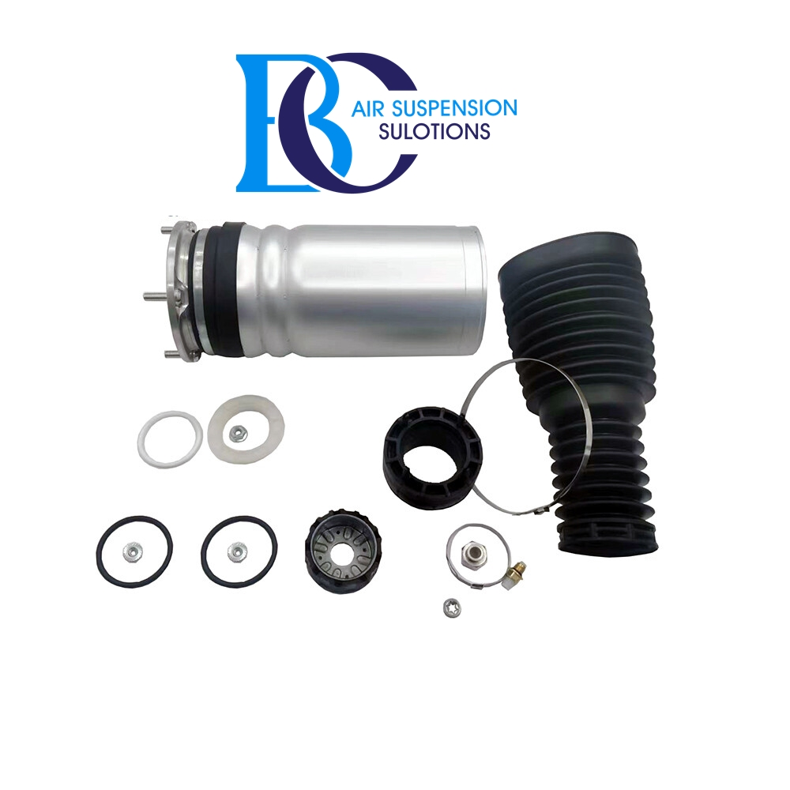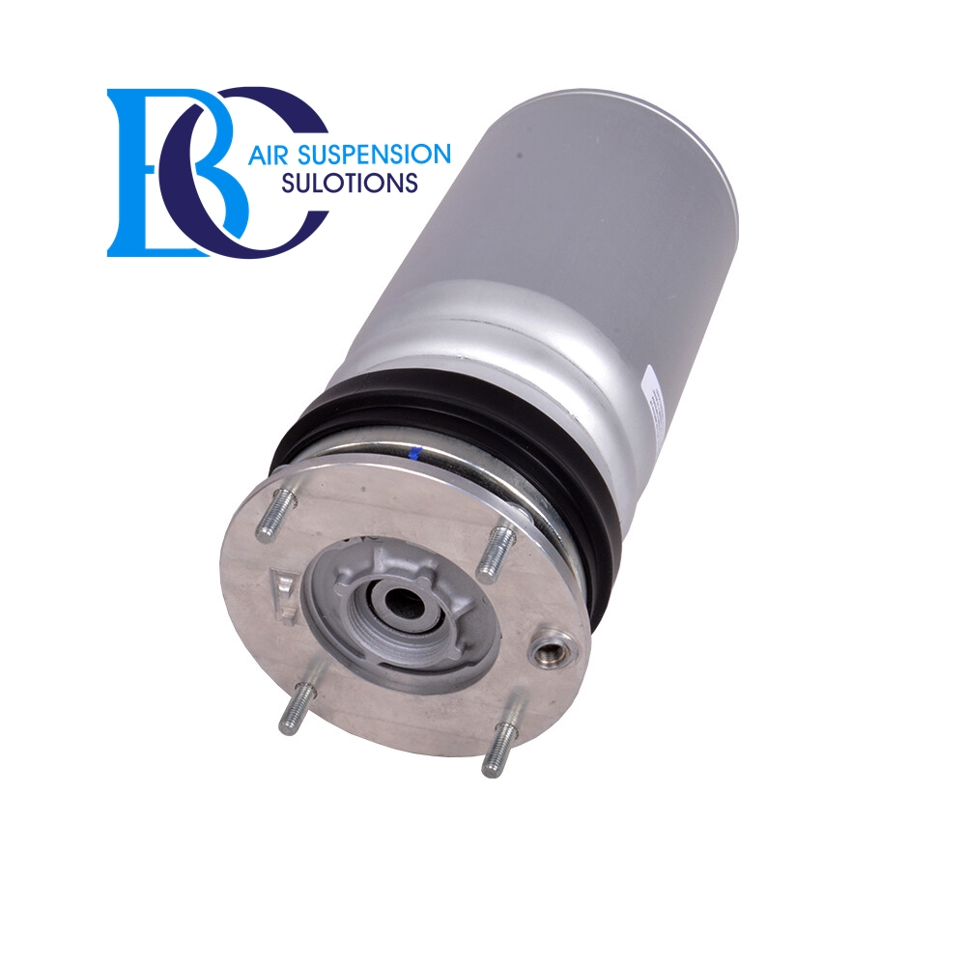

**Description**

This is a kit for the complete suspension strut for Range Rover Sport L405 front side.  
 This kit should not be used for oil leaking shock absorbers.  
   
 **It can be installed in the following vehicles:** Land Rover Range Rover Sport II L494 (2014--)  
   
 **OEM part numbers:** LR087084, LR045832,LR052785,LR057254, LR060402, LR072215, LR045100, LR052784,  
 LR057253, LR060399, LR072450, LR147903, LR087083, LR147904,LR044852,

# **Range Rover SPORT L405 Air springs air suspension, rear**

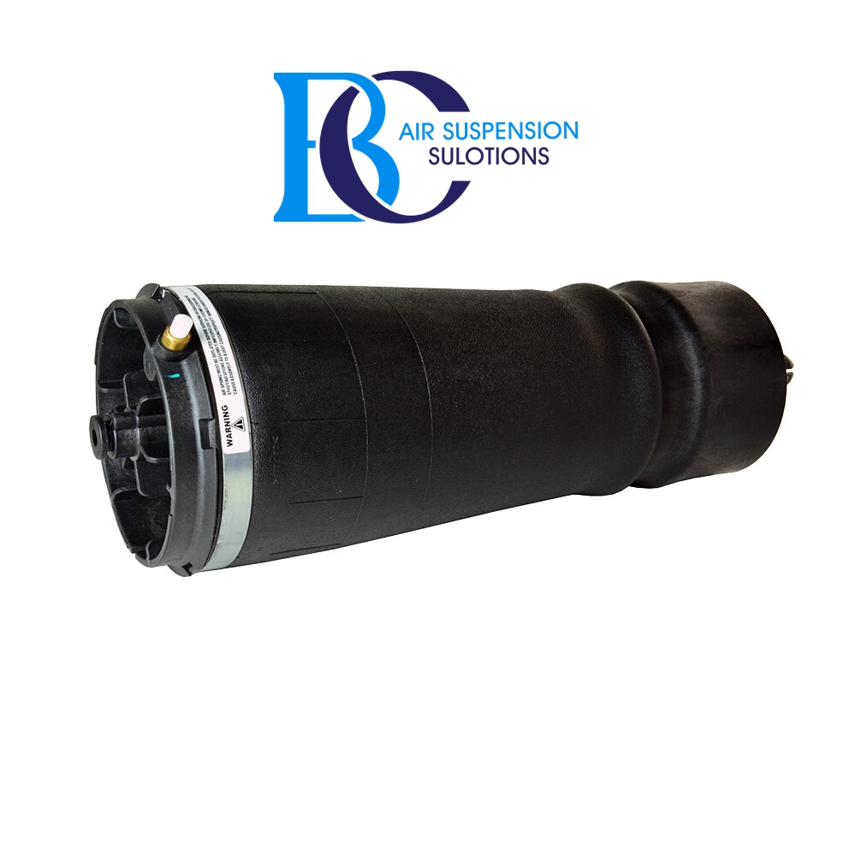

**Description**

This is the rear air spring for the Range Rover SPORT (L405).

**Can be installed in the following vehicles:**

Land Rover Range Rover Sport L494 2013--

**OEM part numbers:**

LR052171,LR044853

# **Land Rover SPORT L405 (2013-2020) Air Compressor air suspension**

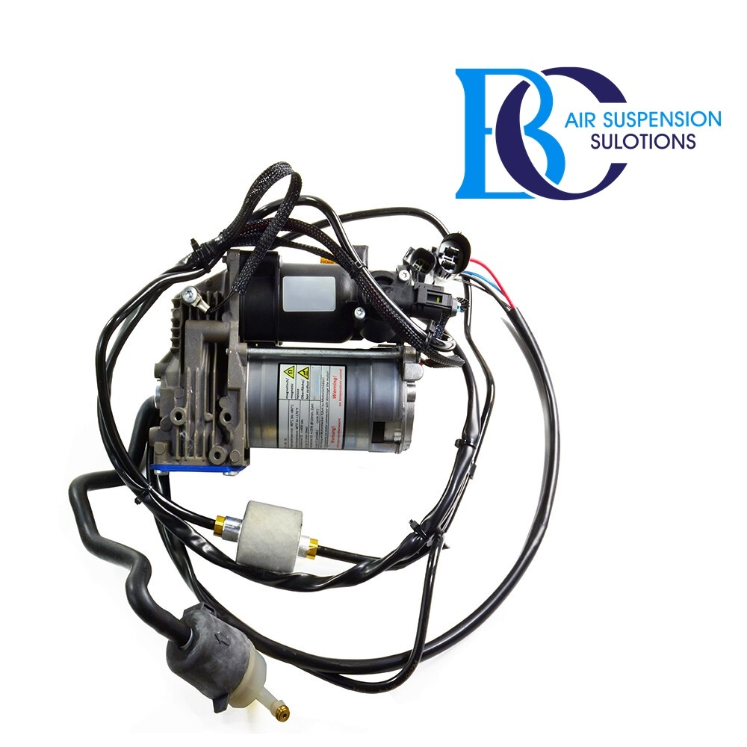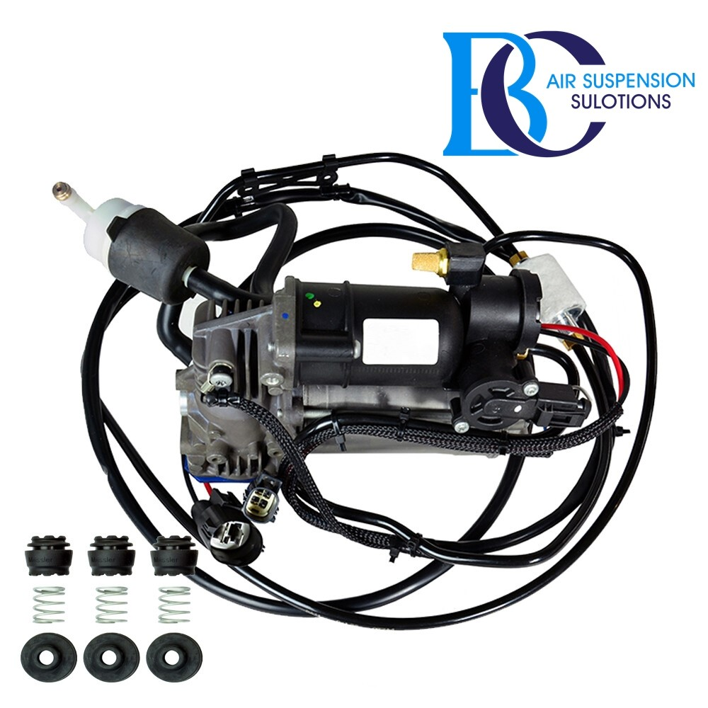

**Description**

This is air compressor for the air suspension of the Land Rover SPORT L405.  
  
 **Can be installed in the following vehicles:** Land Rover Range Rover SPORT L494 (2013-2020)

**Original spare part number:**

LR108984, LR037070, LR044566, LR047172, LR056304, LR069691

# **Land Rover Range Rover SPORT (L405) Valve Air Suspension**

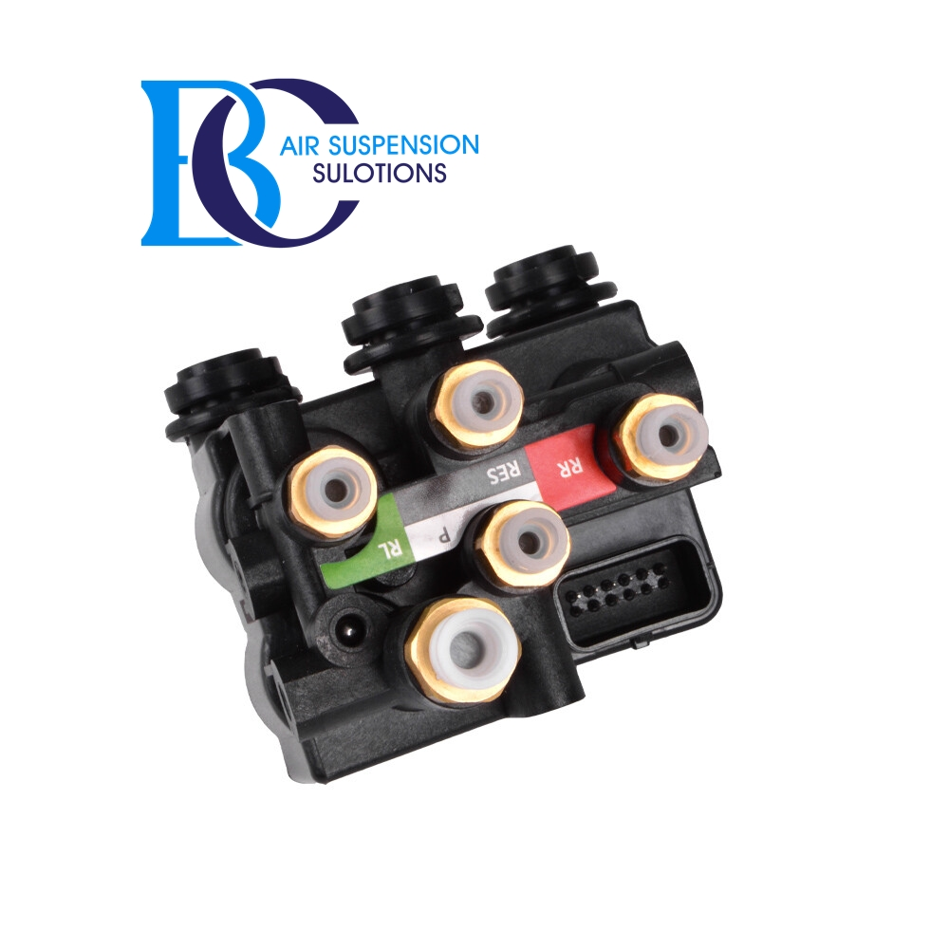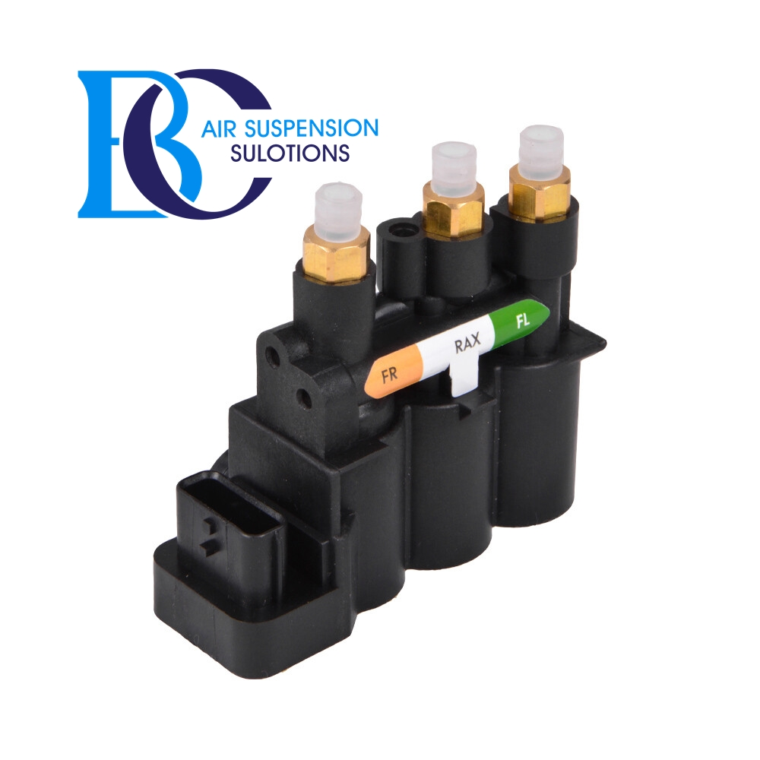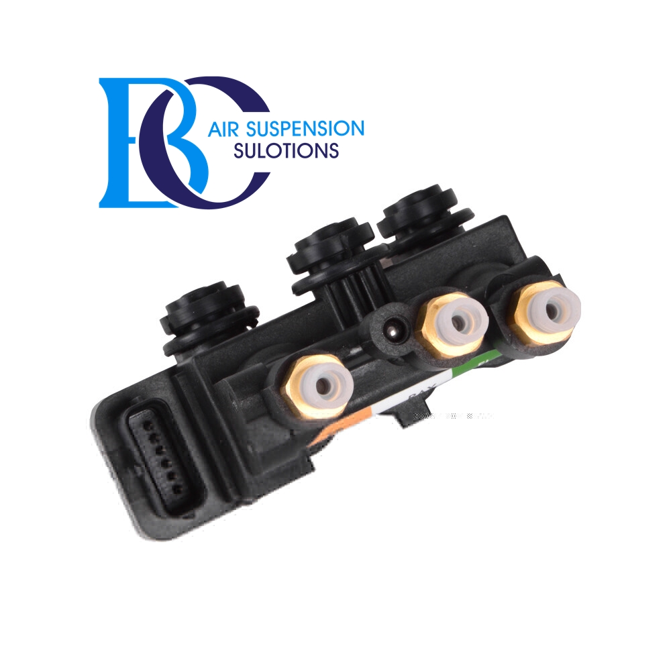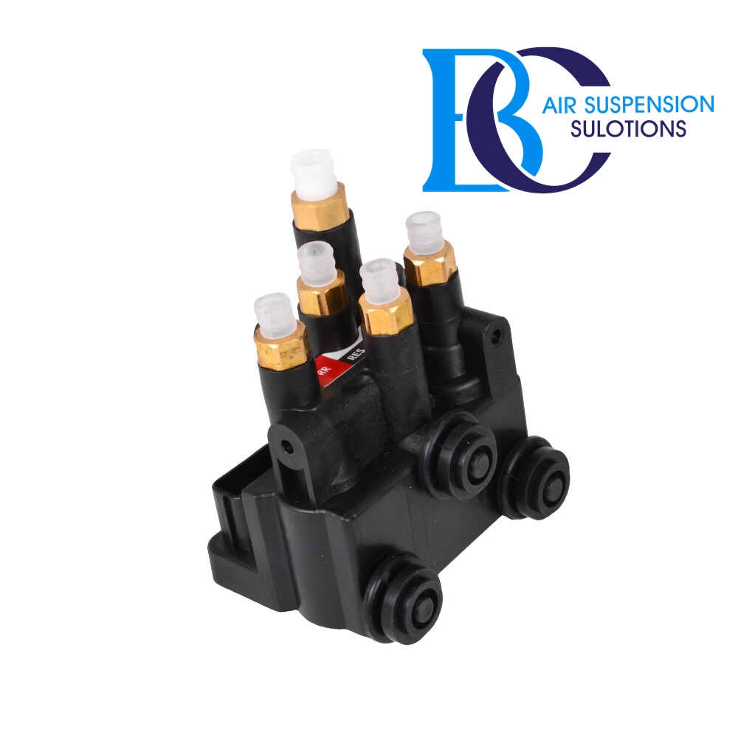

**Description**

This Land Rover Range Rover SPORT (L405) Air Suspension Control Valve regulates the height control of the air suspension.

**Can be installed in the following vehicles:**

Land Rover Range Rover SPORT (L494) 2013--

**Original spare part number:**

LR113342,LR070246,LR037082,LR176326,LR070245,LR037081